**1.**

**Overview of Operating System**

### Definition -:

An operating system (OS) is a software program that acts as an interface between a computer's hardware and its users. It is a fundamental component of any computer system and manages the overall operations of a computer or a network of computers.

* **Dual Mode Operation:-**

Dual mode operation, also known as dual privilege mode or privileged mode, is a feature of modern operating systems that enables a clear distinction between privileged and non-privileged operations. It allows the operating system to protect critical system resources and maintain security by enforcing access control and preventing unauthorized access or manipulation.

In dual mode operation, the processor or CPU (Central Processing Unit) operates in two distinct

1. **User mode:** In this mode, the CPU executes instructions on behalf of user applications or processes. The user mode provides a restricted environment where applications can run,
2. **Kernel mode** (also known as supervisor mode, system mode, or privileged mode): The kernel mode is the higher-privileged mode of operation. In this mode,
3. **Dual mode operation provides several benefits:**
4. **Security:** It allows the operating system to protect critical system resources and prevent unauthorized access or tampering. Only trusted code with appropriate privileges can perform privileged operations.
5. **Stability:** By isolating user applications from the kernel,
6. **Resource Management:** The operating system can effectively manage and allocate system resources by controlling access from user applications

operations such as modifying memory mappings, managing processes, controlling I/O devices, and enforcing security policies

* **OS as a Resource Manager**

An operating system (OS) acts as a resource manager, responsible for efficiently allocating and managing the various hardware and software resources of a computer system. It ensures that these resources are utilized effectively to fulfill the demands of user applications and provide a seamless computing experience. Here are some key aspects of how an OS functions as a resource manager:

1. **CPU Scheduling:** The OS manages the allocation of CPU time among different processes or threads running on the system.
2. **Memory Management:** The OS oversees the allocation and deallocation of memory resources, such as RAM (Random Access Memory), among active processes.
3. **File System Management:** The OS manages the organization, storage, and retrieval of files on storage devices such as hard drives. It provides an interface for creating, modifying, and deleting files .
4. **Device Management:** The OS manages and controls access to various hardware devices connected to the computer system, such as printers, disk drives, network interfaces, and input/output devices.
5. **Network Management:** In networked environments, the OS facilitates communication between computers and network resources. It manages network connections, implements protocols for data transfer, handles network configuration, and provides security measures such as firewalls and encryption.
6. **Process and Thread Management:** The OS creates, schedules, and terminates processes and threads. It manages their execution states, assigns system resources, and facilitates interprocess communication and synchronization.
7. **Security and Access Control:** The OS enforces security policies to protect the system and its resources from unauthorized access and malicious activities.
8. **System Performance Monitoring:** The OS collects and analyzes system performance data, such as CPU usage, memory utilization, and disk I/O.

**Different Types of Operating System**

#### 1. Batch OS 4. Real Time OS

2. Multi-Programmed OS 5. Distributed OS

#### 3. Time-Shared OS 6. Mobile OS

1. **Batch Operating System:-**

A batch operating system is a type of operating system that processes a series of jobs **(also known as batch jobs)** without requiring user interaction during their execution. In a batch processing environment, multiple jobs are submitted to the system as a batch, and the operating system executes them one after another, automatically

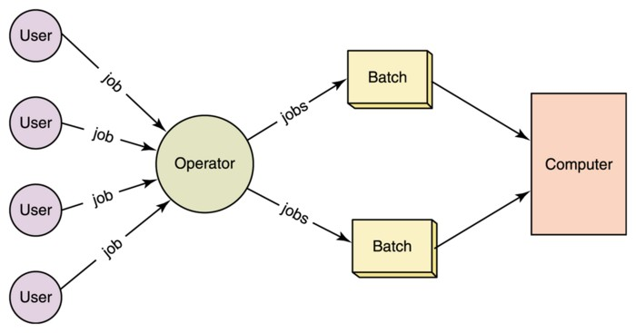

### Advantages of Batch Operating Systems:

1. Increased Efficiency
2. Multiple users can share the batch systems.
3. Automation:
4. Resource Optimization

#### Disadvantages of Batch Operating Systems:

1. Lack of Interactivity.
2. Lack of Flexibility:
3. Poor Responsiveness
4. Limited Error Handling:
5. **Multi-Programming Operating System:-**

A multiprogramming operating system may run many programs on a single processor computer. If one program must wait for an input/output transfer in a multiprogramming operating system, the other programs are ready to use the CPU. As a result,

A multiprogramming operating system, also known as a multitasking operating system, allows multiple programs or tasks to run concurrently on a computer system.

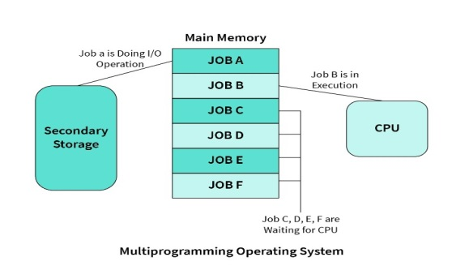

* **Advantage :-**

1. Increased CPU Utilization:
2. Enhanced Throughput.
3. Resource Sharing.
4. Increased Responsiveness
5. Time-sharing:

* **Disadvantages of Multiprogramming :**

1. Complexity
2. Increased Overhead:
3. CPU scheduling is required.
4. Risk of System Instability:
5. Resource Contentions:
6. **Time-Shared Operating System:-**

A **time-shared operating system**, also known as a time-sharing operating system, is an operating system that allows multiple users or processes to share the CPU's time simultaneously. It provides the illusion of each user having dedicated access to the system's resources, even though the resources are actually shared among multiple users.

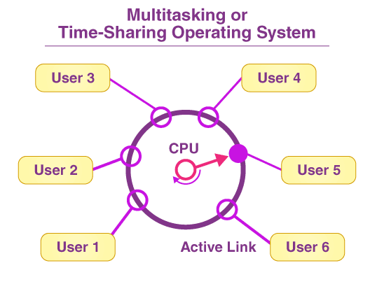

In above figure, the user 5 is active but user 1, user 2, user 3, and user 4 are in waiting state whereas user 6 is in ready status.

* **Advantage of Time Shering OS:-**

1. Efficient Resource Utilization:
2. Increased Productivity:
3. Cost-Effective:.
4. Sharing of Expensive Resources:

* **Diadvantage of Time Shering OS:-**

1. Performance Overhead:.
2. Security and Privacy Concerns
3. Complexity.
4. An issue with the security and integrity of user programs and data.
5. Probability of data communication problem.

**4. Real-time Operating System :-**

A real-time operating system (RTOS) is an operating system designed to meet the specific requirements of real-time applications. Real-time systems are those that must respond to events within strict timing constraints. They are used in a wide range of applications, including industrial control systems,

* **Type of Real-time OS**

1. Hard Real Time OS
2. Soft Real Time OS

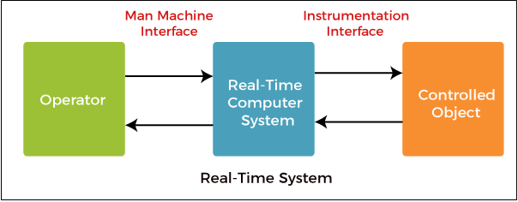

1. **Hard Real Time OS:-**

These operating systems guarantee that critical tasks be completed within a range of time.

For example, a robot is hired to weld a car body. If the robot welds too early or too late, the car cannot be sold, so it is a hard real-time system that requires complete car welding by robot hardly on the time.,

**2. Soft Real Time OS:-**

This operating system provides some relaxation in the time limit.

programmer-defined and controlled processes are encountered in real-time systems.

1. **Distributed Operating System:-**

A **distributed operating system** is an operating system that runs on multiple machines and enables them to work together as a single system. It allows computers and devices in a network to communicate, share resources, and perform tasks in a coordinated manner. A distributed operating system provides transparency and abstraction,

**Types of Distributed System.**

#### Client-Server Systems:-

#### This type of system requires the client to request a resource, Client-Server Systems are also referred to as "Tightly Coupled Operating Systems".

#### Server systems can be divided into two parts:

1. **Computer Server System**

This system allows the interface, and the client then sends its own requests to be executed as an action. After completing the activity, it sends a back response and transfers the result to the client.

#### File Server System

It provides a file system interface for clients, allowing them to execute actions like file creation, updating, deletion, and more.

1. **Peer-to-Peer Systems:-**

The Peer-to-Peer System is known as a "Loosely Couple System". This concept is used in computer network applications since they contain a large number of processors that do not share memory or clocks.

1. **Mobile OS:-**

Android is an open source and Linux-based **Operating System** for mobile devices such as smartphones and tablet computers. Android was developed by the *Open Handset Alliance*, led by Google, and other companies.

The main components of android architecture are following:-

1. Applications :- like home, contacts, camera, gallery
2. Application Framework :- activity manager, notification manager, view system, package manager.
3. Android Runtime :-
4. Platform Libraries :-
5. Linux Kernel:-
6. contacts, camera, gallery etc and third party applications downloaded from the play store like chat applications,
7. Application Framework provides several important classes which are used to create an Android application. It provides a generic abstraction for hardware access and also helps in managing the user interface with application resources. Generally,
8. 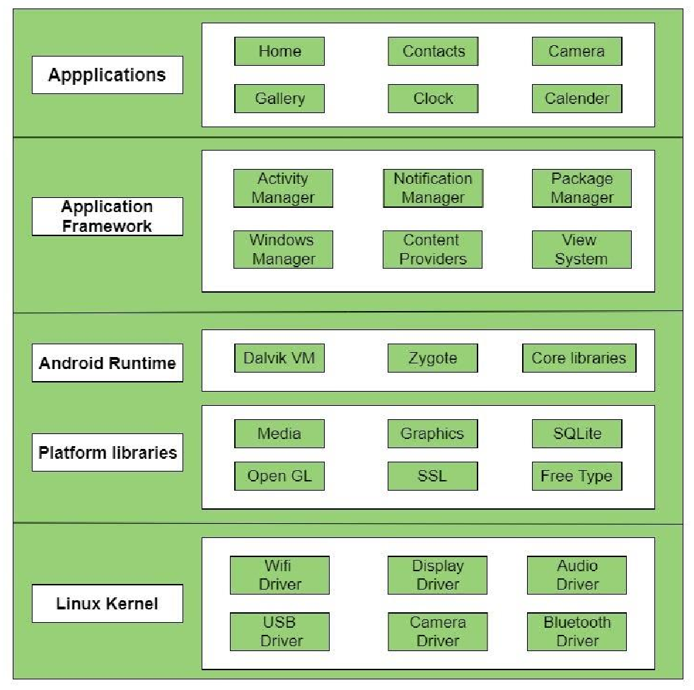The Platform Libraries includes various C/C++ core libraries and Java based libraries such as Media, Graphics, Surface Manager, OpenGL etc. to provide a support for android development

**2.**

**Services & Components of OS**

1. **Services of Operating System:-**

Operating systems provide various services to manage and coordinate the resources and operations of a computer system. Here are some of the different services typically offered by operating systems:

* **Operating System Service:-**

1. **Process Management:**

The operating system manages processes, which are instances of executing programs. It schedules and allocates system resources to processes, handles process creation and termination.

1. **Memory Management:** This service is responsible for managing the computer's memory resources. It tracks and allocates memory space to processes, handles memory allocation and deallocation, and provides mechanisms for virtual memory management and memory protection.
2. **File System Management:** The file system service provides a hierarchical structure for organizing and storing files on storage devices. It manages file creation, deletion, and access permissions, as well as directory management and file metadata (e.g., file size, timestamps).
3. **Device Management**: Operating systems handle interactions with hardware devices, such as keyboards, mice, printers, and storage devices..
4. **User Interface:** The operating system provides a user interface that allows users to interact with the computer system. This can include command-line interfaces (CLI), graphical user interfaces (GUI), or a combination of both, enabling users to execute commands, launch applications, and manage files.
5. **Network Management:** Operating systems include networking services that enable communication and data transfer over computer networks. They provide network protocols, manage network connections, handle data transmission, and support various network configurations.

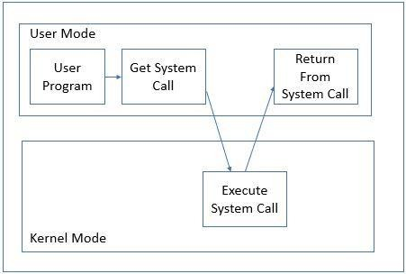System calls are fundamental functions provided by an operating system that allow user-level programs to request services from the operating system kernel. They act as an interface between user applications and the underlying operating system .

**System Calls:**

**1. File System Operations:-** System calls such as "open," "**read**," "**write**," and "**close**" are used for file manipulation. They allow programs to create, open, read from, write to, and close files.

**2. Process Management**:- System calls like "**fork**," "**exec**," "**exit**," and "**wait**" are used for managing processes. They allow programs to create new processes,

**3. Device Management**:- System calls such as "**open**," "**read**," "**write**," and "**ioctl**" are used to interact with hardware devices.

**4.Memory Management:-** System calls like "brk" and "mmap" are used for memory management.

**5.Network Operations:-** System calls such as "socket," "connect," "send," and "recv" are used for network communication

**6.Time and Date Management:-** System calls like "time," "gettimeofday," and "sleep" are used to obtain and manipulate system time and dates

**7.Process Control**: System calls like "kill" and "signal" are used for process control. They allow programs to send signals to processes, handle signal events,

**8.Interprocess Communication (IPC):-** System calls such as "pipe," "shmget," "msgget," and "semget" are used for interprocess communication.

**Components of OS**

An Operating system is an interface between users and the hardware of a computer system. It is a system software that is viewed as an organized collection of software consisting of procedures and functions,

* **Important Components of the Operating System:-**

#### 1.Process Management :-

A process is a program in execution. It consists of the followings:

Executable program ,Program’s data ,Stack and stack pointer ,Program counter

#### 2.Files Management :-

#### Files are used for long-term storage. Files are used for both input and output. Every operating system provides a file management service.include

File creation , File deletion , Read and Write operations

#### 3.Command Interpreter :

Command interpreter provides a **command-line interface**. It allows the user to enter a command on the command line prompt (cmd).

**4.System Calls :**

System calls provide an interface to the services made by an operating system. The user interacts with the operating system programs through System calls.

#### 5.Network Management :-

Network management is a fundamental concept of computer networks. Network Management Systems is a software application that provides network administrators with information on components in their networks.

#### 6.Security Management:

. Security management refers to the various processes where the user changes the file, memory, CPU, and other hardware resources.

#### 7.I/O Device Management :

The I/O device management component is an I/O manager that hides the details of hardware devices and manages the main memory for devices.

#### 8.Secondary Storage Management :

the secondary storage area is any space, where data is stored permanently and the user can retrieve it easily. Your computer’s hard drive is the primary location for your files and programs. Other spaces, such as CD- ROM/DVD drives, flash memory cards, and networked devices,

**9.Main memory management :-** Main memory is also called Random Access Memory (RAM), Main memory is a flexible and volatile type of storage device.

**Operating System Tools**